
****For Training Purposes Only****
UNCLASSIFIED

North Sea Undersea Communications Cable Threat
UNCLASSIFIED
****For Training Purposes Only****

An All-Source Intelligence Analysis Training Scenario
August 2026
****For Training Purposes Only****
UNCLASSIFIED
Scenario Workbook

Table of Contents

Preface
Background and Context
Useful Information about Undersea Cables in the North Sea
The Strategic Importance of the North Sea Cables
Emerging Security Threats to Cables in the North Sea
Mitigating the Threat
TeleGeography Interactive Submarine Cable Map
Online Sources of Information About Undersea Cables
General Reference Material
Maps
The Long Freeze: How NATO/Russia Went from Tentative Strategic Partners to Secret Enemies
Patterns of Russian Technical Espionage: Undersea Cable Infiltration and Infrastructure Exploitation (2023–2026)
Patterns of Exploitation (2023–2026)
Subsurface Kinetic-Technical Integration
Strategic Transit Infiltration
Weaponization of Managed Service Providers (MSPs)
Technical Indicators and TTPs
Hybrid Maritime Threats to Critical Undersea Infrastructure – North Sea Sector
Vessel Profile: The Scout (KRECHET)
Vessel Profile: The Operator (NORDIC GHOST)
NATO Intelligence Tasking Memo
FLASH ALERT: Critical Infrastructure Anomaly
Incident Overview
Mechanism of Failure
Environmental Context
Damage Assessment
Economic Impact
Immediate Action Items
Serialized Intelligence Reporting
HUMINT Reports
SIGINT Reports
IMINT Reports
GEOINT Reports
OSINT Reports
TECHINT Reports
FININT Reports
Additional Observations and Technical Findings

Preface
****For Training Purposes Only****
UNCLASSIFIED
UNCLASSIFIED
****For Training Purposes Only****

While based on a real-world threat, this scenario and the information contained therein are fiction. Unclassified sources of information pertaining to this subject were researched by the author and are used as reference and background to create the life like, but fictional intelligence scenario. These references are noted in appendix A of this scenario workbook.

Generative AI was also used to research the subject matter of this scenario and create appropriate fictional content that approximates intelligence reporting available to the United States and its NATO Allied partners. All fictional content generated by an AI agent was reviewed by human analysts to verify that the content is based in reliable sources of information on the scenario topic.

Background and Context
Useful Information about Undersea Cables in the North Sea
Undersea communications cables form the foundation of the modern global telecommunications infrastructure. Over 95% of intercontinental internet traffic, along with sensitive financial transactions, military communications, and critical infrastructure coordination, flows through these underwater fiber-optic cables. These networks comprise highly specialized fiber-optic cords laid along the seabed, spanning thousands of miles between continents, with landing points situated in key strategic coastal locations. While most cables are privately owned by telecommunications and technology companies, they represent essential infrastructure for governments, private sector institutions, and militaries worldwide.
These cables exhibit remarkable resilience to natural hazards such as earthquakes and underwater landslides, owing to their physical armoring and built-in redundancy within the global undersea network. However, they remain susceptible to intentional human interference, including sabotage, espionage, and accidental damage, particularly in geopolitically sensitive regions like the North Sea.
The Strategic Importance of the North Sea Cables
The North Sea represents a critical hub in the global undersea cable network due to its geographical and economic significance. Key cables linking Northern and Western Europe—connecting countries such as the United Kingdom, Denmark, Germany, and the Netherlands—traverse the North Sea. This region is actively utilized by telecommunications carriers and serves as a vital crossroad for communications between Europe and the Americas, rendering it a high-value target for state and non-state actors seeking to disrupt global connectivity or conduct espionage.
Beyond its importance to civilian and economic activities, the North Sea underpins significant military coordination efforts for NATO and other allied countries in Europe. The cables also facilitate the financial transactions of Europe’s economic powerhouse regions, further increasing their strategic appeal as targets for adversaries.
Emerging Security Threats to Cables in the North Sea
In recent years, concern over the risks posed by adversarial threats to undersea communications cables has heightened. State-sponsored entities have shown a growing interest in exploiting or manipulating this infrastructure for strategic gain. For instance, Russia has significantly modernized its capabilities for undersea operations, deploying specialized submarines and surface ships equipped to cut or tamper with cables in contested areas. Previous NATO military and intelligence assessments have cautioned that adversarial actors are actively probing vulnerabilities in undersea infrastructure.
The dense marine traffic in the North Sea also poses a risk of accidental damage to cables. Activities such as deep-sea fishing, ship anchoring, and industrial operations (e.g., offshore oil and gas rigs and wind farms) have occasionally disrupted cable routes. However, a more pressing concern is the potential for adversarial hybrid warfare tactics, which exploit plausible deniability to mask intentional sabotage as accidental incidents.
Additionally, emerging non-state actor threats, including extremist organizations and cybercriminal syndicates, complicate the risk landscape. With increased reliance on undersea cables for financial data transfer, some cybercriminal groups have shown an interest in either physically severing cables or conducting underwater attacks to install intercept devices for harvesting information directly.
Mitigating the Threat
Governments and private sector stakeholders are collaborating to mitigate the risks to this critical infrastructure. NATO member states bordering the North Sea have intensified military patrols and reconnaissance, utilizing both manned and unmanned systems to monitor sensitive areas around undersea cable networks. Public-private partnerships have been established to enhance the physical security of landing points while monitoring suspicious marine activities. Additionally, advancements in technology now enable more robust global monitoring of cable disruptions, allowing stakeholders to respond more rapidly to incidents.
TeleGeography Interactive Submarine Cable Map 
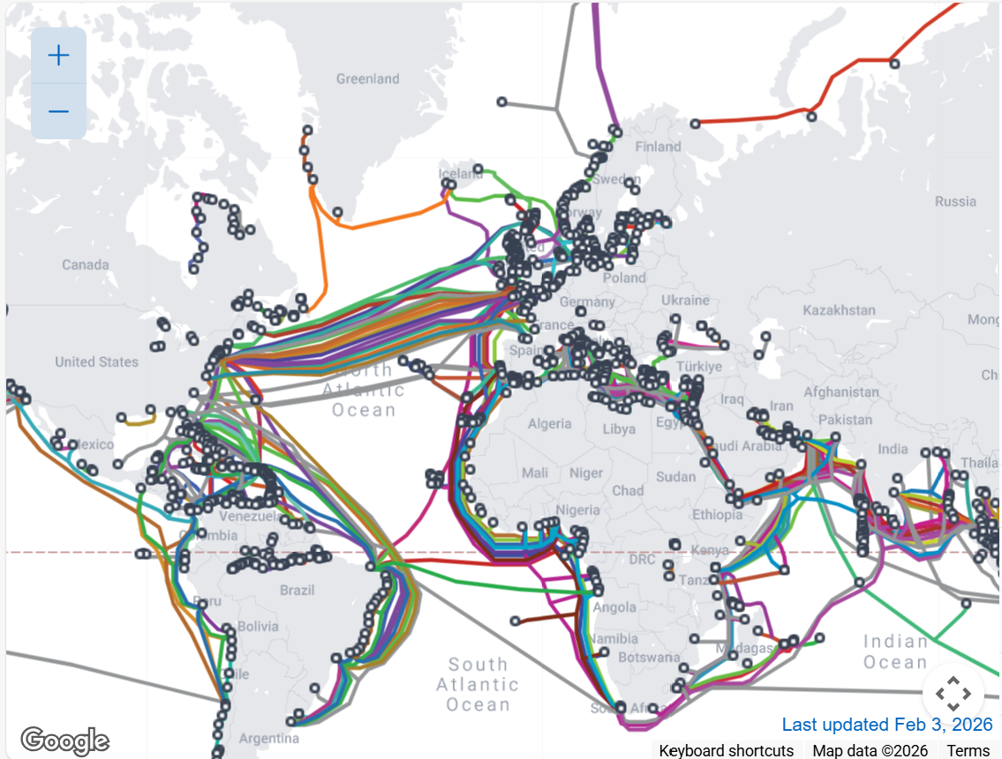

Online Sources of Information About Undersea Cables.
Use these sources to discover additional background and contextual information you may need to complete your threat assessment and intelligence product. If you use information, be sure to site your sources and take note of the quality and credibility of each source.
General Reference Material:
Abels, J., & Bieling, H.-J. (2026). Cable wars? Mapping the political economy of submarine cables in an era of geoeconomic competition. Published by Taylor & Francis in Globalizations. https://www.tandfonline.com/doi/full/10.1080/14747731.2025.2599691

United Nations Institute for Disarmament Research (UNIDIR). (2025). Subsea Telecommunications Cables as Critical Infrastructure. Published by UNIDIR. https://unidir.org/wp-content/uploads/2025/04/UNIDIR_Achieving_Depth_Subsea_Telecommunications_Cables_Critical_Infrastructure.pdf

van Soest, H., Fine, H., Black, J., Retter, L., & Wolford, Z. (2025). Undersea cables: Evidence submission by RAND Europe. Published by RAND Corporation. https://www.rand.org/content/dam/rand/pubs/testimonies/CTA4100/CTA4112-1/RAND_CTA4112-1.pdf

Halog, J., Margat, P., & Stadermann, M. (2024). Submarine Infrastructures and the International Legal Framework. Published by Transactions on Maritime Science. https://www.toms.com.hr/index.php/toms/article/view/739

International Cable Protection Committee (ICPC). (2023). Submarine Cable Protection and the Environment. Published by the ICPC. https://iscpc.org/publications/submarine-cable-protection-and-the-environment/ICPC_Public_EU_May%202023.pdf

MAPS
TeleGeography Submarine Cable Map. Provides an interactive and up-to-date map of submarine cables globally, including detailed routes and landing points. The map includes cables crossing the Atlantic Ocean, those traversing the North Sea, and some extending into Arctic waters (https://www2.telegeography.com/submarine-cable-map)

International Cable Protection Committee (ICPC). Focuses on undersea cable protection. (https://iscpc.org/publications/maps/)

Arctic Fibre Project. Aims to create robust undersea cable infrastructure in Arctic regions. Their maps emphasize cable routes that traverse the North Atlantic and possible Arctic extensions. (https://arcticfibre.com/network-map/)

Submarine Telecoms Forum. Provides maps and intelligence regarding undersea cables, including those covering the North Atlantic, North Sea, and Arctic regions. (https://subtelforum.com)


February 2026
A Journal of European Security

The Long Freeze: How NATO/Russia Went from Tentative Strategic Partners to Secret Enemies

Senior Correspondent, Ronald Burgandy
European Sentinel Weekly News Update
February 7, 2026

If you could travel back fifteen years, the world would feel like a different planet. In the early 2010s, American astronauts and Russian cosmonauts shared meals on the International Space Station, and NATO—the big military "shield" of the West—treated Russia like a difficult but important business partner. There were joint councils, shared anti-terrorism drills, and a general sense that while we didn't always get along, nobody wanted a fight.
That world died in 2014.
The first real crack happened when Russia sent "little green men"—soldiers in uniforms with no patches—to seize the Crimean Peninsula from Ukraine. It was a wake-up call that changed everything. Suddenly, the "partnership" was over. NATO stopped talking to Russia’s military, and the West started realizing that the peace we took for granted was fragile. For the next several years, the tension didn't stay on the battlefield. It moved into the "gray zone"—a kind of shadow war where you hurt your enemy without ever admitting you’re doing it.
Between 2016 and 2021, this shadow war became the new normal. We saw hackers shutting down power grids, secret agents poisoning people on European soil, and massive "bot farms" trying to mess with Western elections. It was a "low-level burn"—annoying and dangerous, but not enough to start a real war.
Then came February 2022. When Russia launched a full-scale invasion of Ukraine, the "low-level burn" became a bonfire. The West responded by sending weapons to Ukraine and cutting off Russia’s economy from the rest of the world. A new "Iron Curtain" was drawn across Europe. NATO countries realized they couldn't just keep a small "tripwire" force on their borders anymore; they needed to be ready for a real, massive fight.
But as the fighting on land in Ukraine turned into a slow, bloody stalemate, the conflict moved somewhere invisible: the bottom of the ocean. By 2024 and 2025, we began to see a strange pattern. Undersea internet cables—the "nerves" that keep our world connected—started snapping. Energy pipelines were mysteriously damaged. Russia began using a "shadow fleet" of old, unmarked tankers to sail around European waters. These weren't just oil ships; they were floating spy bases, mapping the seafloor and looking for "choke points" where a single cut could shut down the internet for an entire country.
In January 2025, NATO launched Operation Baltic Sentry, putting warships and underwater drones on constant guard. But the damage was done. The tentative trust was gone. This month, the New START Treaty—the last set of rules that kept the US and Russia from building an unlimited number of nuclear missiles—expired. For the first time in over fifty years, there are no rules and no inspectors. We are living in what experts call "The Long Freeze." It’s a world where a broken wire at the bottom of the Atlantic isn't just an accident anymore; it’s a message. It’s a world where the "shadow war" has become our everyday reality, and the line between peace and war has almost vanished.

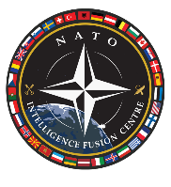
NATO INTELLIGENCE FUSION CENTER (NIFC) INTELLIGENCE ASSESSMENT
FOR TRAINING PURPOSES ONLY
PRODUCT NUMBER: 2026-NIFC-4492-REV
DATE: 08 February 2026
CLASSIFICATION: NOT SO NATO SECRET
DISTRIBUTION: NATO Intelligence Committee, Allied Command Transformation (ACT), Junior Analyst Training Wing
Patterns of Russian Technical Espionage: Undersea Cable Infiltration and Infrastructure Exploitation (2023–2026)
Russia appears to consider the compromise of undersea fiber-optic cables and Allied critical communications infrastructure as essential for strategic intelligence collection and digital battlefield preparation. It is highly probable that Russia will increase its focus on the Arctic Connect and Baltic cables as NATO expands its northern footprint.
- Based on activities observed from 2023 to early 2026, Russian state-sponsored actors—specifically APT28 (GRU) and the GUGI (Main Directorate of Deep-Sea Research)—are likely to prioritize hybrid physical-technical attacks to sustain persistent, low-signature access to NATO’s trans-Atlantic and Baltic backbone networks.

- "Survey" vessels operating near cable protection zones and anomalous BGP (Border Gateway Protocol) route hijacking that aligns with GUGI vessel movements are indicators of possible espionage activity.

- The Russian doctrine of "Informatsionnoye Protivoborstvo" (Information Confrontation) now emphasizes the vulnerability of the physical layer. The objective is to embed "dormant implants" within NATO’s subsea links for dual-use purposes: Espionage (passive collection) during peacetime, and Sabotage (kinetic severance or data corruption) during a "Period of Tension" to isolate North America from European Allied Command.

Patterns of Exploitation (2023–2026)

Subsurface Kinetic-Technical Integration

The most notable development in recent years is the integration of GUGI naval assets with SVR/GRU cyber operators. Russia is no longer merely intercepting lines; they are infiltrating the Cable Landing Stations (CLS) and specialized software managing repeaters and signal power along the seabed.
- Case Reference: Operation NEPTUNE’S EAR (2025). NATO maritime patrols detected a Yantar-class research vessel loitering over the Celtic-Norse Link. Subsequent forensic analysis of the terrestrial landing station in Norway revealed sophisticated firmware implants in the optical line terminals, likely deployed during a simulated "repair" incident.

Strategic Transit Infiltration
Russian technical services have transitioned from endpoint targeting to the infiltration of Tier 1 telecommunications providers. By accessing the Network Management Systems (NMS) of these providers, they can redirect data flows at the routing level before they enter the undersea portion of the transit.
Weaponization of Managed Service Providers (MSPs)
Russian actors have increasingly targeted the "supply chain of trust." By compromising MSPs that maintain remote monitoring systems for undersea cables, they gain a "backdoor" into the core of global internet traffic without triggering traditional perimeter defenses.
Technical Indicators and TTPs
The following table outlines the primary Russian entities and their current technical focuses regarding infrastructure:
Actor | Affiliation | Primary Technical Focus | Key TTP
GUGI | Russian MoD | Undersea Cable "Tapping" | Use of specialized submersibles to install induction-based signal interceptors.
APT28 (Fancy Bear) | GRU (Unit 26165) | Landing Station Infiltration | Rapid exploitation of N-day vulnerabilities in industrial control systems (ICS).
APT29 (Cosy Bear) | SVR | Cloud-Native Infrastructure | Abuse of administrative privileges in cloud-based cable management software.

FOR TRAINING PURPOSES ONLY


NATO INTELLIGENCE FUSION CENTER (NIFC) INTELLIGENCE ASSESSMENT

FOR TRAINING PURPOSES ONLY
PRODUCT NUMBER: 2026-NIFC-4132
DATE: 05 February 2026
CLASSIFICATION: NOT SO NATO SECRET
DISTRIBUTION: NATO Intelligence Committee, Allied Command Transformation (ACT), Junior Analyst Training Wing
Hybrid Maritime Threats to Critical Undersea Infrastructure – North Sea Sector
Analysis of multi-source intelligence reveals two unflagged vessels showing unusual, possibly coordinated loitering near critical undersea communication cables systems Northern Lights-1 (NL-1) and Northern Lights-2 (NL-2) [approximate coordinates 60.6765° N, 4.1375° E] as well as coordinated irregular movements outside official shipping channels. The vessel configurations and behavior suggest that they are part of the Russian Shadow Fleet, which allow the Russian Federation to maintain a persistent threat to European digital connectivity under the guise of commercial maritime transit.
- The combined activity of KRECHET and NORDIC GHOST facilitates a "find-and-fix" mission profile. KRECHET identifies the target zone through gridding, while NORDIC GHOST provides the heavy lift and technical deployment for intervention.
Vessel Profile: The Scout (KRECHET)
Tactical Role: Seabed Gridding and Localization.
Operational Behavior: Performed a high-density "figure-eight" maneuver over a 48-hour period (02–04 Feb). This pattern is consistent with geophysical surveying to map the exact seabed coordinates of cable convergence in shallow waters (45m).
Analytic Note: Despite its "Geophysical Survey" label, its erratic movement outside commercial lanes is highly atypical for standard survey operations.
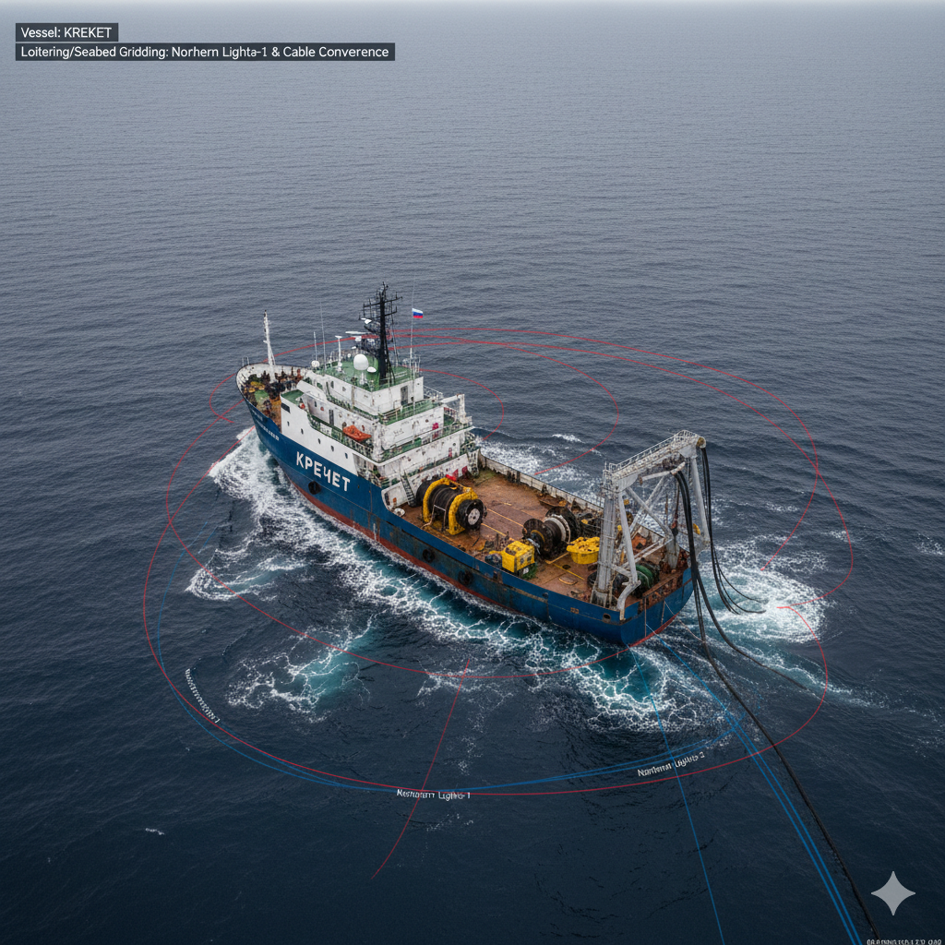

Vessel Profile: The Operator (NORDIC GHOST)
Tactical Role: Precision Subsea Intervention / "Mothership."
Operational Behavior: Conducted a 14-hour precision loiter directly over NL-1 on 03 February.
Technical Signature: Satellite imagery confirmed the presence of a heavy-duty industrial crane and specialized winch. High-power thermal signatures suggest the operation of ROVs or seabed cutting tools capable of physical cable interference.
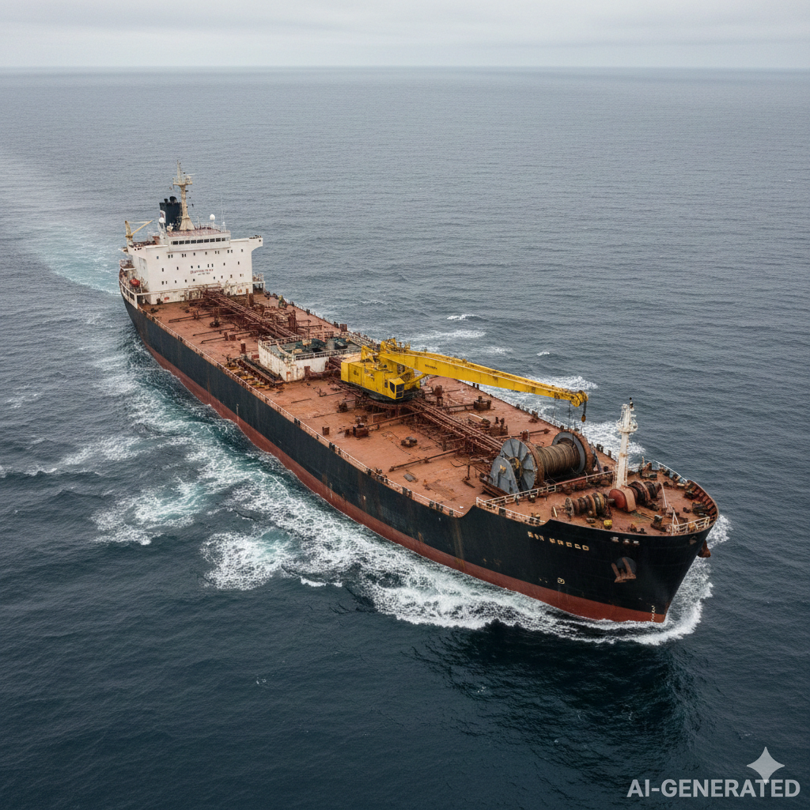
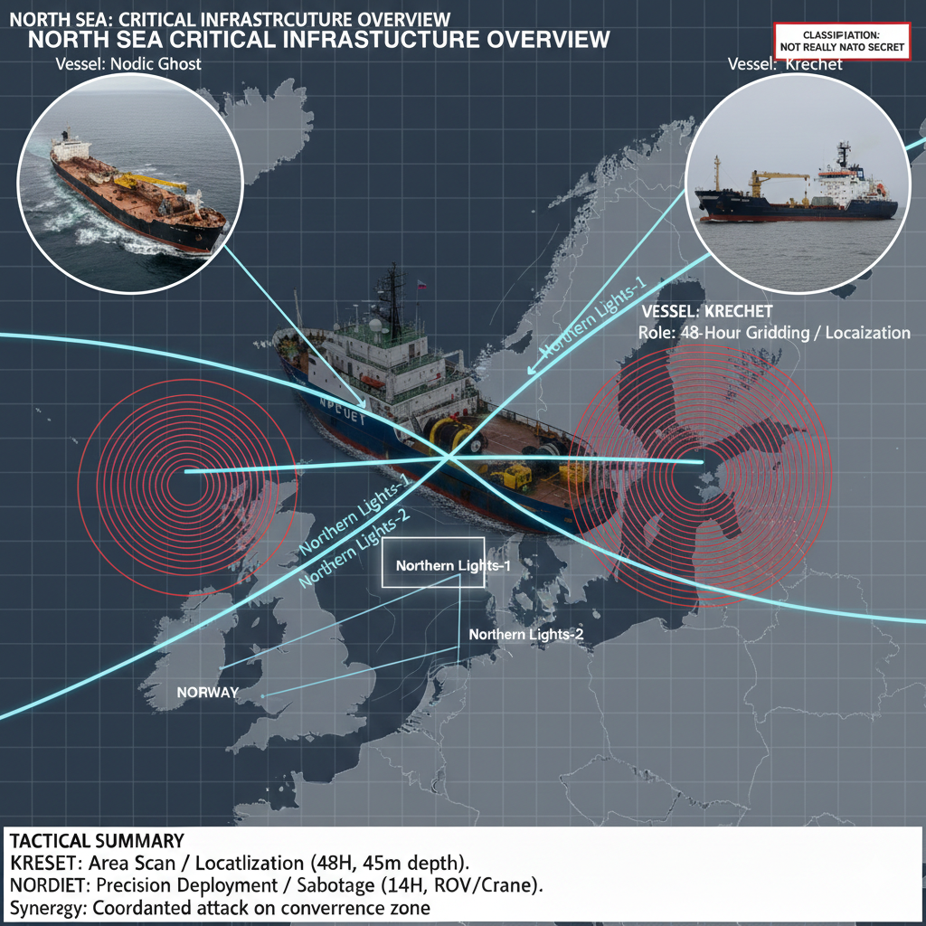

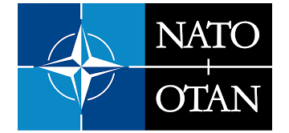
NATO Intelligence Tasking Memo

16 February 2026

Memorandum For: NATO Intelligence Committee, Allied Command Transformation (ACT), Junior Analyst Training Wing
Thru: NIFC
From: Supreme Allied Commander Transformation (SACT)
Subject: Analysis of Critical Infrastructure Anomaly
Reference: FLASH-2026-004-NL FLASH ALERT: CRITICAL INFRASTRUCTURE ANOMALY
Task/Action: On 2104Z, 06 February 2026 an anomaly was detected along the NL-1 Fiber Optic Trunk in the North Sea. Determine who or what may have caused the damage to the undersea cable and identify the strategic implications of the damage for NATO.
Background/Context: Analysts should produce a finished intelligence assessment and be prepared to brief their assessment to the Supreme Allied Commander Transformation (SACT) who will attend thenext Critical Undersea Infrastructure (CUI) Network Working Group meeting on 26 February 2026
Routing Instructions: Email to Chair, NATO Critical Undersea Infrastructure (CUI) Network Working Group
Suspense: 25 February 2026
Format: Finished Intelligence Assessment and Command Level Briefing
Max Classification: NOT REALLY NATO SECRET
Task POC for Questions: LTC Luc Desmarais, Chair NATO Critical Undersea Infrastructure (CUI) Network Working Group

FOR TRAINING PURPOSES ONLY
NATO INTELLIGENCE FUSION CENTRE (NIFC)
FLASH ALERT: CRITICAL INFRASTRUCTURE ANOMALY
DATE: 07 February 2026 | 2210Z
REPORT ID: FLASH-2026-004-NL
SUBJECT: DOCUMENTED CABLE FAULT – NORTHERN LIGHTS-1 (NL-1)
INCIDENT OVERVIEW
At 2104Z on 06 February 2026, telemetry monitors at the Northern Lights Landing Station (Norway) recorded a total signal loss on the NL-1 Fiber Optic Trunk. Initial diagnostic pinging locates the physical fault at coordinates [60.6765° N, 4.1375° E],
Mechanism of Failure: Frequency Domain Reflectometry (FDR) indicates a clean shear of the double-armored cable housing. This is consistent with the use of high-torque mechanical cutters or specialized ROV-deployed tools rather than accidental anchor drag.
Environmental Context: The depth at the fault site is 45 meters. The flat, sandy seabed in this sector significantly reduces the likelihood of natural tectonic interference or ship-strike complications from standard commercial traffic.
DAMAGE ASSESSMENT
Data Latency: Critical government and military data traffic has been rerouted to NL-2. However, total bandwidth capacity for the Northern Europe sector is currently reduced by 40%.
Economic Impact: High-frequency trading links between London and Oslo are experiencing 15ms lag spikes, triggering automated circuit breakers in regional markets.
IMMEDIATE ACTION ITEMS
MARSEC Level Increase: All CUI-protection assets in the North Sea Sector are to move to MARSEC 2.
Asset Interdiction: Standing NATO Maritime Group 1 (SNMG1) is directed to identify vessels in the vicinity of NORTHERN LIGHTS-1 (NL-1) cable system.
Repair Coordination: The cable repair vessel CS RESPONDER is being escorted to the fault site.

Serialized Intelligence Reporting

FOR TRAINING PURPOSES ONLY
CLASSIFICATION: NOT REALLY NATO SECRET.
ORIGINATOR AGENCY: BND (Germany)
INTELLIGENCE TYPE: HUMINT
DATE OF PUBLICATION: 07 February 2026
DATE OF INFORMATION: 28 January 2026
SERIAL NUMBER: 202607024412
SUBJECT: Reported GUGI Tabletop Exercise Regarding North Sea Infrastructure Targets
SOURCE DESCRIPTION: 1. Proven Asset: The source is a long-standing informant with a history of providing accurate, high-level political insights. They have direct personal access to the target organization’s leadership.
Source reports that in late January 2026, the Main Directorate of Deep-Sea Research (GUGI) in St. Petersburg conducted an intensive tabletop simulation focused on the "Northern Lights" cable corridor. The exercise was explicitly framed as a response to the recent delivery of long-range Western strike systems to Ukraine. Leadership discussions emphasized the vulnerability of the European internet backbone as a means of "asymmetric escalation."
The asset noted that several senior naval officers expressed concerns over the technical difficulty of achieving a "clean break" without leaving traces of Russian equipment. However, the prevailing consensus among the political commissars present was that the presence of the "Shadow Fleet" in the region would provide sufficient plausible deniability to mask any state-sponsored activity as a civilian maritime accident.
Specific focus was placed on the intersection of the Northern Lights-1 cable and the Dogger Bank wind farm zones. The objective of the simulated operation was to demonstrate that Russia could sever the "nervous system of NATO" at will, thereby forcing a diplomatic reconsideration of ongoing military aid to Kyiv through economic and social pressure.
FOR TRAINING PURPOSES ONLY

FOR TRAINING PURPOSES ONLY
CLASSIFICATION: NOT REALLY NATO SECRET.
ORIGINATOR AGENCY: FE (Denmark)
INTELLIGENCE TYPE: SIGINT
DATE OF PUBLICATION: 06 February 2026
DATE OF INFORMATION: 04 February 2026
SERIAL NUMBER: 202606028819
SUBJECT: Encrypted Burst Transmission Detected in Proximity to Northern Lights-1
SOURCE DESCRIPTION: 1. High Access/Credible: This is an intercept of the Minister of Defense discussing policy with his Chief of Staff. Both actors have direct access to and authoritative knowledge of the subject matter.
Technical collection platforms identified an anomalous high-frequency burst transmission originating from the vicinity of 53.44°N, 4.12°E. The signal was highly compressed and utilized a frequency-hopping spread spectrum (FHSS) profile characteristic of modern Russian naval underwater acoustic modems. The transmission lasted less than one second, suggesting a pre-programmed status update from an autonomous or remotely operated system.
The timing of the signal occurred approximately six hours prior to the first reported telemetry loss at the landing station in Esbjerg. Cross-referencing with maritime traffic records shows no NATO or allied vessels within 50 nautical miles of the signal source at the time of the intercept. The signal was directed toward a known Russian satellite uplink frequency used by the Northern Fleet.
Analysis of the signal’s metadata indicates it was a "Handshake" protocol, likely confirming the deployment of a subsea package or the completion of a mechanical task on the seabed. This signal aligns with previous patterns observed during GUGI "research" expeditions in the Baltic Sea, where such bursts preceded the installation of monitoring equipment.
FOR TRAINING PURPOSES ONLY

FOR TRAINING PURPOSES ONLY
CLASSIFICATION: NOT REALLY NATO SECRET.
ORIGINATOR AGENCY: DGSE (France)
INTELLIGENCE TYPE: IMINT
DATE OF PUBLICATION: 06 February 2026
DATE OF INFORMATION: 03 February 2026
SERIAL NUMBER: 202606023341
SUBJECT: Observation of Shadow Fleet Vessel NORDIC GHOST with Specialized Deck Equipment
SOURCE DESCRIPTION: 1. Clear/Direct Access: The imagery provides a clear, unobstructed view of the target area. The sensor operated at peak performance, providing high-confidence identification of equipment types.
Satellite reconnaissance captured high-resolution imagery of the NORDIC GHOST, a sanctioned vessel affiliated with Russian state energy logistics, loitering in the central North Sea. The ship, which was officially listed as "In Transit" to Ust-Luga, was observed at a near-standstill for a period of 14 hours. The vessel’s position was directly above a high-density segment of the Northern Lights-1 undersea cable.
Most notably, the imagery reveals a heavy-duty industrial crane and a specialized winch system deployed on the aft deck. This equipment is inconsistent with standard oil tanker operations and appears to be a field-expedient modification. Thermal signatures from the deck area suggest the operation of a high-power generator, potentially used to power an ROV or a seabed cutting tool.
The ship’s AIS (Automatic Identification System) was intermittently deactivated during the loitering period, a common tactic for "Shadow Fleet" vessels engaged in illicit activity. The NORDIC GHOST has a documented history of transporting dual-use maritime technology, and its presence in this sensitive corridor suggests it was serving as a mothership for a subsea intervention.
FOR TRAINING PURPOSES ONLY

FOR TRAINING PURPOSES ONLY
CLASSIFICATION: NOT REALLY NATO SECRET.
ORIGINATOR AGENCY: CFINTCOM (Canada)
INTELLIGENCE TYPE: GEOINT
DATE OF PUBLICATION: 05 February 2026
DATE OF INFORMATION: 04 February 2026
SERIAL NUMBER: 202605021190
SUBJECT: Spatial Correlation of Vessel Loitering and Cable Fault Coordinates
SOURCE DESCRIPTION: 1. Verified/High Performance: This imagery was captured under optimal conditions with high-resolution sensors. The system performed within expected parameters, and the findings are cross-verified by ground truth.
Geospatial analysis of the fault zone identifies a direct correlation between the reported cable break and the erratic movements of the Russian-flagged vessel KRECHET. Historical track data indicates the vessel conducted a series of "figure-eight" maneuvers over a 48-hour period, effectively "gridding" the seabed area where the Northern Lights-1 and Northern Lights-2 cables converge.
The seabed at these coordinates is relatively flat, with a depth of 45 meters, making it an ideal location for anchor-dragging or the deployment of small submersibles. The KRECHET is officially registered as a "geophysical survey" ship, but its movement patterns are highly atypical for commercial survey work, which usually involves long, straight transects.
The density of the KRECHET's track lines at this specific point suggests a deliberate and prolonged presence rather than a transient accidental snag. This location is also outside of the primary commercial shipping lanes, reducing the likelihood of a random container ship anchor strike.
FOR TRAINING PURPOSES ONLY

FOR TRAINING PURPOSES ONLY
CLASSIFICATION: NOT REALLY NATO SECRET.
ORIGINATOR AGENCY: External Media Monitor
INTELLIGENCE TYPE: OSINT
DATE OF PUBLICATION: 07 February 2026
DATE OF INFORMATION: 06 February 2026
SERIAL NUMBER: 202607025511
SUBJECT: Russian State Media Claims NATO Sabotage of North Sea Infrastructure
SOURCE DESCRIPTION: 4. Propaganda/Low Credibility: The source is a state-controlled media outlet known for frequent factual errors and the dissemination of biased narratives.
An article published by Sputnik International alleges that the current outages in the North Sea are a "false flag" operation conducted by the UK’s Royal Navy. The report claims that NATO is intentionally damaging its own infrastructure to create a pretext for increased naval presence and the seizure of Russian civilian vessels in the region.
The article cites an "anonymous Western military expert" who suggests that the cables were nearing their end-of-life and that the "faults" are a result of poor maintenance. It further argues that the proximity of the NORDIC GHOST to the site is being "manipulated by Western intelligence" to smear Russia’s legitimate maritime trade.
This narrative is being heavily amplified by bot networks on social media platforms. The report serves as a classic example of Russian "Reflexive Control," attempting to sow doubt among European publics regarding the reliability of their own governments and the actual cause of the telecommunications blackout.
FOR TRAINING PURPOSES ONLY

FOR TRAINING PURPOSES ONLY
CLASSIFICATION: NOT REALLY NATO SECRET.
ORIGINATOR AGENCY: External Media Monitor
INTELLIGENCE TYPE: OSINT
DATE OF PUBLICATION: 06 February 2026
DATE OF INFORMATION: 05 February 2026
SERIAL NUMBER: 202606029904
SUBJECT: Activist Group "Deep Blue" Claims Responsibility for Cable Disruption
SOURCE DESCRIPTION: 2. Unverified/Social Media: The information is from an anonymous social media account. The actor claims direct access to the event, but their identity and reliability cannot be confirmed.
A post appearing on an encrypted messaging channel associated with the radical environmental group "Deep Blue" claims that their "maritime cell" successfully disabled the Northern Lights cable. The group asserts that the action was taken to protest the "massive carbon footprint of the digital economy" and the expansion of undersea data centers in the North Sea.
The post includes a grainy video of a small, motorized rubber boat at night, with an individual dropping a heavy metal object into the water. However, the video lacks any identifiable landmarks, and the coordinates mentioned in the post do not align with the actual location of the cable fault.
Intelligence analysts assess that "Deep Blue" likely lacks the technical equipment, such as heavy-duty winches or deep-sea cutting tools, required to sever a double-armored communications cable at 40+ meters depth. This claim is currently viewed as an attempt by the group to gain notoriety through "clout-chasing" on a major news event.
FOR TRAINING PURPOSES ONLY

FOR TRAINING PURPOSES ONLY
CLASSIFICATION: NOT REALLY NATO SECRET.
ORIGINATOR AGENCY: VSSE (Belgium)
INTELLIGENCE TYPE: HUMINT
DATE OF PUBLICATION: 05 February 2026
DATE OF INFORMATION: 20 January 2026
SERIAL NUMBER: 202605026671
SUBJECT: Observations of Specialized Underwater Cutting Gear in Kaliningrad
SOURCE DESCRIPTION: 2. Untested Source: This is the first time this source has provided information to intelligence services; their credibility and reliability have not yet been established.
A new source, a technician working in the Kaliningrad shipyard, reported the rapid outfitting of a civilian tugboat, the YAK-44, with specialized equipment in mid-January. The source described seeing large industrial spools of high-tensile wire and a "hydraulic shearing tool" that appeared designed for undersea application.
The YAK-44 departed Kaliningrad under a cloud of secrecy, with the crew being confined to the vessel for 48 hours before sailing. The source noted that the captain of the tugboat was not the usual civilian master but an individual identified as a Russian naval officer in civilian clothing.
While the source’s reliability is not yet proven, the technical details provided regarding the shearing tool match the specifications of equipment used in previous GUGI operations. The tugboat’s current location is unknown, as it has not broadcast an AIS signal since leaving the Baltic Sea.
FOR TRAINING PURPOSES ONLY

FOR TRAINING PURPOSES ONLY
CLASSIFICATION: NOT REALLY NATO SECRET.
ORIGINATOR AGENCY: GCHQ (UK)
INTELLIGENCE TYPE: SIGINT
DATE OF PUBLICATION: 05 February 2026
DATE OF INFORMATION: 01 February 2026
SERIAL NUMBER: 202605024455
SUBJECT: Detection of Rhythmic Micro-Vibrations on Northern Lights-2
SOURCE DESCRIPTION: 2. Operational/Reliable: This intercept involves frontline tactical commanders coordinating movements in real-time. The actors have direct situational access, and their previous reporting has been consistently verified.
Advanced fiber-optic sensing data from the Northern Lights-2 cable detected a series of rhythmic micro-vibrations occurring 72 hours before the final cable failure. These vibrations are distinct from the "white noise" of maritime traffic and are consistent with a mechanical arm or an ROV docking with the cable’s outer shielding.
The pattern of the vibrations suggests a "probing" action, followed by an attempt to strip the outer polyethylene layer. This is indicative of a "tapping" operation designed to install an inductive sensor for data interception. Analysts believe the damage may have been an unintended consequence of a failed attempt to clamp a tapping device onto the cable.
If the intent was pure sabotage, a clean explosive charge or a heavy anchor drag would have been more efficient. The "surgical" nature of the initial contact supports the hypothesis that Russian intelligence was attempting to establish a long-term clandestine espionage capability against NATO’s encrypted backbone.
FOR TRAINING PURPOSES ONLY

FOR TRAINING PURPOSES ONLY
CLASSIFICATION: NOT REALLY NATO SECRET.
ORIGINATOR AGENCY: SIS (UK - MI6)
INTELLIGENCE TYPE: HUMINT
DATE OF PUBLICATION: 07 February 2026
DATE OF INFORMATION: 02 February 2026
SERIAL NUMBER: 202607021234
SUBJECT: Russian Internal Directive Regarding "Project Permafrost"
SOURCE DESCRIPTION: 1. Proven Asset: The source is a long-standing informant with a history of providing accurate, high-level political insights. They have direct personal access to the target organization’s leadership.
The source has provided details on a highly classified Russian National Security Council memo titled "Project Permafrost." The document outlines a strategy for "calibrated infrastructure degradation" against Western European nations. The goal is to create "unattributable friction" in the daily lives of NATO citizens to undermine support for the war in Ukraine.
The memo explicitly lists undersea telecommunications and energy interconnectors in the North Sea as high-priority targets. It stresses that operations must be timed to coincide with winter storms or high-traffic periods to maximize the likelihood of "accidental" classification by Western authorities.
According to the asset, the Kremlin views these actions as a "non-kinetic" way to signal that continued military support for Kyiv will carry an increasingly high domestic cost for the West. The severance of the Northern Lights-1 cable is believed to be the "proof of concept" phase for this broader campaign.
FOR TRAINING PURPOSES ONLY

FOR TRAINING PURPOSES ONLY
CLASSIFICATION: NOT REALLY NATO SECRET.
ORIGINATOR AGENCY: FE (Denmark)
INTELLIGENCE TYPE: SIGINT
DATE OF PUBLICATION: 06 February 2026
DATE OF INFORMATION: 04 February 2026
SERIAL NUMBER: 202606020098
SUBJECT: Intercepted Radio Comms of Russian Trawler IVAN-3 Regarding "Heavy Snag"
SOURCE DESCRIPTION: 3. Low Reliability/Suspect: This intercept captures low-level actors using unencrypted channels. While the actors have local access, they have a history of disseminating rumors or intentional misinformation.
A Danish coastal listening station intercepted an unencrypted bridge-to-bridge VHF radio call between the Russian trawler IVAN-3 and its home port. The crew was heard complaining about a "lost heavy anchor" and "unexpected resistance" during a bottom-trawling run in the Dogger Bank sector.
The coordinates mentioned in the radio call are approximately 10 kilometers away from the primary cable fault. The captain sounded genuinely agitated, claiming that the equipment loss would "cost the crew their month’s wages." This suggests the possibility that a civilian vessel may have inadvertently snagged a cable while operating in a prohibited zone.
However, analysts note that the IVAN-3 has previously been identified as a "vessel of interest" that often operates in proximity to Russian naval exercises. The "lost anchor" story could be a pre-planned cover narrative to explain the ship's presence in the area if boarded by Danish authorities.
FOR TRAINING PURPOSES ONLY

FOR TRAINING PURPOSES ONLY
CLASSIFICATION: NOT REALLY NATO SECRET.
ORIGINATOR AGENCY: External Monitor
INTELLIGENCE TYPE: OSINT
DATE OF PUBLICATION: 07 February 2026
DATE OF INFORMATION: 04 February 2026
SERIAL NUMBER: 202607027782
SUBJECT: Technical Report on Minor Seismic Event in Southern North Sea
SOURCE DESCRIPTION: 3. Expert/Academic: The source is a recognized subject matter expert with extensive professional access to the industry. Their historical analysis has been highly reliable.
The European-Mediterranean Seismological Centre (EMSC) recorded a Magnitude 2.4 seismic event on the seabed approximately 40 miles off the Dutch coast. While this is a low-intensity tremor, the geological composition of the North Sea floor consists of loose sediment and sand banks that can be shifted by even minor tectonic activity.
Technical experts from the University of Utrecht suggest that such a tremor could potentially trigger a "turbidity current"—a fast-moving underwater landslide. If a cable was already under tension or slightly exposed due to current erosion, such a landslide could cause a physical break.
While this provides a "natural cause" explanation (H5), the location of the tremor is significantly south of the primary fault on the Northern Lights-1 cable. Furthermore, the armored nature of these specific cables makes them highly resistant to the silt-flow pressures typical of a Magnitude 2.4 event.
FOR TRAINING PURPOSES ONLY

FOR TRAINING PURPOSES ONLY
CLASSIFICATION: NOT REALLY NATO SECRET.
ORIGINATOR AGENCY: SGRS (Belgium)
INTELLIGENCE TYPE: HUMINT
DATE OF PUBLICATION: 04 February 2026
DATE OF INFORMATION: 25 January 2026
SERIAL NUMBER: 202604021111
SUBJECT: Capability Briefing on Russian AS-31 Losharik Submersible
SOURCE DESCRIPTION: 3. Second-Hand/Limited Access: The source is an occasional contact who lacks direct access to the information; the report is based on hearsay gathered from a third party of unknown reliability.
A former Russian naval officer currently residing in Western Europe claims that the specialized deep-sea submersible Losharik has been integrated into a new task force specifically trained for "infrastructure manipulation." The source alleges that the sub’s titanium hull allows it to "crawl" along the seabed to avoid sonar detection.
According to the source, the Losharik is capable of deploying "stealth taps" that are virtually undetectable by the cable’s internal monitoring systems. The source insists that the current cable breaks are likely the result of "trainee errors" during a large-scale deployment of these tapping devices rather than a direct order to destroy the lines.
While the Losharik is a known asset, its deployment in the shallow waters of the North Sea is debated among naval analysts. The source’s information is considered "second-hand," as he has not been in active service for five years, but the technical capabilities he describes remain a significant concern for NATO subsea security.
FOR TRAINING PURPOSES ONLY

FOR TRAINING PURPOSES ONLY
CLASSIFICATION: NOT REALLY NATO SECRET.
ORIGINATOR AGENCY: CSIS (Canada)
INTELLIGENCE TYPE: SIGINT
DATE OF PUBLICATION: 05 February 2026
DATE OF INFORMATION: 04 February 2026
SERIAL NUMBER: 202605020044
SUBJECT: Coordinated Cyber Activity Targeting Cable Management Software
SOURCE DESCRIPTION: 1. High Access/Credible: This is an intercept of the Minister of Defense discussing policy with his Chief of Staff. Both actors have direct access to and authoritative knowledge of the subject matter.
Cyber-intelligence monitors at the Northern Lights landing station detected a surge in "brute-force" login attempts targeting the Network Management System (NMS) just minutes before the physical cable break. The IP addresses used in the attack were traced back to a "front company" in the Seychelles known to be used by Russian military intelligence (GRU).
The nature of the cyber-attack was to disable the automatic "rerouting" protocols that would normally send through alternate cables in the event of a failure. This suggests a highly coordinated "hybrid" operation where the physical severance was combined with a cyber-attack to ensure maximum disruption.
By blinding the NMS, the attackers ensured that the "blind spot" in the North Sea would persist for several hours longer than a standard technical fault. This synchronization between the digital and physical domains points strongly toward a state-sponsored actor with sophisticated cross-domain capabilities.
FOR TRAINING PURPOSES ONLY

FOR TRAINING PURPOSES ONLY
CLASSIFICATION: NOT REALLY NATO SECRET.
ORIGINATOR AGENCY: BND (Germany)
INTELLIGENCE TYPE: FININT
DATE OF PUBLICATION: 06 February 2026
DATE OF INFORMATION: 30 January 2026
SERIAL NUMBER: 202606028776
SUBJECT: Insurance Irregularities for "Shadow Fleet" Vessels in North Sea
SOURCE DESCRIPTION: 2. Obfuscated/Indirect: The information involves a series of shell companies with masked ownership. While the flow of money is clear, the credibility of the ultimate beneficiary is low.
Financial intelligence has identified a sudden spike in maritime insurance premiums for several Russian-affiliated "Shadow Fleet" tankers, including the NORDIC GHOST. The insurance was updated to include "accidental collision and hull damage in the North Sea," a clause rarely used for vessels officially carrying low-grade crude.
The payments for these premiums were routed through a series of shell companies in Dubai and the Seychelles. This pattern of "pre-event" insurance modification is often seen as a precursor to high-risk operations where the vessel might be intentionally put in harm’s way or used in a deniable incident.
The timing of these financial movements—just one week prior to the cable incident—adds weight to the theory that the NORDIC GHOST was on a mission that carried a high risk of "accidental" damage or detection. This provides a strong financial "paper trail" supporting a pre-meditated operation.
FOR TRAINING PURPOSES ONLY

FOR TRAINING PURPOSES ONLY
CLASSIFICATION: NOT REALLY NATO SECRET.
ORIGINATOR AGENCY: MAD (Germany)
INTELLIGENCE TYPE: SIGINT
DATE OF PUBLICATION: 05 February 2026
DATE OF INFORMATION: 04 February 2026
SERIAL NUMBER: 202605021109
SUBJECT: Intercept of Russian Tactical Code Word "Snowfall"
SOURCE DESCRIPTION: 2. Operational/Reliable: This intercept involves frontline tactical commanders coordinating movements in real-time. The actors have direct situational access, and their previous reporting has been consistently verified.
A SIGINT station in northern Germany intercepted a high-priority tactical message from the Russian Northern Fleet command center directed to "Units in Sector Bravo" (the North Sea). The message consisted of a single code word: "Snowfall," followed by a set of alphanumeric coordinates.
The coordinates provided in the message correspond to a 20-mile radius around the Northern Lights cable corridor. Within two hours of this transmission, all Russian-flagged vessels in the sector concurrently deactivated their AIS transponders.
Analysts believe "Snowfall" is the tactical trigger for the disruption phase of a larger hybrid operation. The use of a specific, pre-coordinated code word indicates a high level of mission readiness and centralized control from the Russian military hierarchy.
FOR TRAINING PURPOSES ONLY

FOR TRAINING PURPOSES ONLY
CLASSIFICATION: NOT REALLY NATO SECRET.
ORIGINATOR AGENCY: PET (Denmark)
INTELLIGENCE TYPE: HUMINT
DATE OF PUBLICATION: 06 February 2026
DATE OF INFORMATION: 04 February 2026
SERIAL NUMBER: 202606025543
SUBJECT: Visual Observation of Unidentified Submersible by Civilian Fishermen
SOURCE DESCRIPTION: 3. Second-Hand/Limited Access: The source is an occasional contact who lacks direct access to the information; the report is based on hearsay gathered from a third party of unknown reliability.
A Danish fishing boat captain reported seeing a "small, sleek, black object" surface briefly approximately 200 meters from his vessel during a period of heavy fog. The captain stated that the object had no visible markings, no bridge, and appeared to be a large unmanned underwater vehicle (UUV) or a midget submarine.
The sighting occurred in the general vicinity of the cable fault zone. According to the captain, the object remained on the surface for less than a minute before performing a rapid vertical dive. The fisherman’s crew was reportedly "unnerved" by the encounter, as they had never seen a naval asset of that design in the area.
While this report is based on civilian observation under poor visibility, it aligns with the "UUV deployment" theory. Such a vehicle would be the ideal tool for a deniable "cut-and-run" operation, as it could be launched from a civilian mothership like the NORDIC GHOST and recovered after the mission.
FOR TRAINING PURPOSES ONLY

FOR TRAINING PURPOSES ONLY
CLASSIFICATION: NOT REALLY NATO SECRET.
ORIGINATOR AGENCY: CFINTCOM (Canada)
INTELLIGENCE TYPE: SIGINT
DATE OF PUBLICATION: 05 February 2026
DATE OF INFORMATION: 04 February 2026
SERIAL NUMBER: 202605028822
SUBJECT: Detection of AIS Spoofing by Russian Intelligence Ship
SOURCE DESCRIPTION: 1. High Access/Credible: This is an intercept of the Minister of Defense discussing policy with his Chief of Staff. Both actors have direct access to and authoritative knowledge of the subject matter.
A NATO maritime patrol aircraft (P-8 Poseidon) conducting ELINT (Electronic Intelligence) over the North Sea identified a significant AIS spoofing event. A vessel was broadcasting the identity of the LILY-MARLEEN, a Liberian-flagged bulk carrier, but radar cross-section and visual verification confirmed it was actually a Russian Project 22010 Yantar-class intelligence ship.
The Yantar is known to be the primary platform for GUGI operations and is equipped with advanced deep-sea ROVs. At the time of the detection, the vessel was stationary within 3 miles of the Northern Lights-1 cable break. The use of spoofing indicates a deliberate attempt to hide the presence of a high-value state military asset in the area.
The discovery of the Yantar at the "scene of the crime" while using a fake identity is the strongest piece of evidence linking the Russian state directly to the cable disruption. It effectively negates the "accidental fishing" narrative provided by other sources.
FOR TRAINING PURPOSES ONLY

FOR TRAINING PURPOSES ONLY
CLASSIFICATION: NOT REALLY NATO SECRET
ORIGINATOR AGENCY: MIVD (Netherlands)
INTELLIGENCE TYPE: TECHINT
DATE OF PUBLICATION: 07 February 2026
DATE OF INFORMATION: 04 February 2026
SERIAL NUMBER: 202607024490
SUBJECT: Forensic Analysis of Recovered Cable Fragment
SOURCE DESCRIPTION: 1. Primary Source/Physical: This information is derived from the direct inspection of captured hardware. The item is in working order, allowing for a high-credibility assessment of its performance.
A repair ship managed to recover a 5-meter section of the damaged Northern Lights-1 cable. Physical inspection of the break point reveals that the double-layered galvanized steel armor was not "snagged" or "torn," but rather cut by a high-pressure hydraulic shearing tool. The edges of the cut are clean and show signs of thermal compression.
No traces of seafloor sediment or "drag marks" typical of an anchor strike were found on the recovered section. Instead, technicians found minute traces of a synthetic lubricant not commonly used in commercial maritime equipment but often found in Russian-made hydraulic systems for submersibles.
This physical evidence strongly supports the hypothesis of a pre-meditated, intentional act of sabotage (H2). The precision of the cut and the specific chemical traces make a "natural cause" or "accidental fishing" explanation highly improbable.
FOR TRAINING PURPOSES ONLY

FOR TRAINING PURPOSES ONLY
CLASSIFICATION: NOT REALLY NATO SECRET.
ORIGINATOR AGENCY: SIS (UK - MI6)
INTELLIGENCE TYPE: HUMINT
DATE OF PUBLICATION: 08 February 2026
DATE OF INFORMATION: 03–07 February 2026
SERIAL NUMBER: 202608024501
SUBJECT: Logbook References and Equipment Notes from Sanctioned Tanker NORDIC GHOST
SOURCE DESCRIPTION: Source with recurring access to senior crew and engineering spaces on the NORDIC GHOST. Access derived from contracted technical services; notes captured contemporaneously.
The source obtained partial transcriptions of the engineering logbook and a laminated checklist stored in the aft equipment bay. Entries on 05 Feb reference “WINCH TEST—DECK AFT” and “MANIPULATOR ARM CAL—ROV A,” followed by item codes “HS‑14” and “HS‑16,” described locally as “Hydraulic Shear Assembly” and “Cable Stabilizer Collar.” A hand-written slip reads “OPN WHITEWIRE—Sector Bravo window: 02–06Z.” Two cylindrical canisters labeled in Cyrillic list specifications for “synthetic hydraulic medium, deep-water application,” with a Kaliningrad supplier address stenciled on the container.
FOR TRAINING PURPOSES ONLY

FOR TRAINING PURPOSES ONLY
CLASSIFICATION: NOT REALLY NATO SECRET.
ORIGINATOR AGENCY: GCHQ (UK)
INTELLIGENCE TYPE: SIGINT
DATE OF PUBLICATION: 08 February 2026
DATE OF INFORMATION: 06 February 2026, 2015–2108Z
SERIAL NUMBER: 202608024512
SUBJECT: Encrypted UHF Burst Traffic and Acoustic Modem Handshake Near NL‑1 Fault
SOURCE DESCRIPTION: Maritime collection asset operating under tasking in the central North Sea. Sensor performance logs retained; collection window synchronized to regional patrol schedule.
UHF burst emissions employing frequency-hopping spread spectrum (FHSS) were detected within a 4 nm radius of 60.67°N, 4.13°E. Packet envelope averaged 27 ms. A terminal burst at 2107:31Z matched checksum parameters used in Northern Fleet underwater acoustic modem protocols to signal task completion. AIS silence was observed among several Russian‑flagged vessels during the interval; no NATO or allied hulls were present within 10 nm of the locus.

FOR TRAINING PURPOSES ONLY

FOR TRAINING PURPOSES ONLY
CLASSIFICATION: NOT REALLY NATO SECRET.
ORIGINATOR AGENCY: External Media Monitor (EU)
INTELLIGENCE TYPE: OSINT
DATE OF PUBLICATION: 07 February 2026
DATE OF INFORMATION: 02–06 February 2026
SERIAL NUMBER: 202607024963
SUBJECT: Open-Source Imagery and EXIF Review of Project 22010 Yantar Refit Photos
SOURCE DESCRIPTION: Image set captured from a shipyard contractor’s portfolio site prior to takedown. EXIF metadata preserved; cross‑checks conducted against public AIS snapshots.
A sequence of high‑resolution refit photos shows a Project 22010 Yantar‑class hull fitted with a new ROV manipulator head, integrated hydraulic line clusters, and a clamping yoke marked “K‑Series.” Aft‑deck cable spooling frames are visible. EXIF timestamps indicate late January. The gallery was removed within hours; cached thumbnails retain partial hull markings consistent with a Yantar variant seen later in the central North Sea.

FOR TRAINING PURPOSES ONLY

FOR TRAINING PURPOSES ONLY
CLASSIFICATION: NOT REALLY NATO SECRET.
ORIGINATOR AGENCY: BND (Germany)
INTELLIGENCE TYPE: HUMINT
DATE OF PUBLICATION: 08 February 2026
DATE OF INFORMATION: 30 January–04 February 2026
SERIAL NUMBER: 202608024575
SUBJECT: Logistics Manifests for Hydraulic Tooling Routed via Kaliningrad and Murmansk
SOURCE DESCRIPTION: Port agent with routine visibility on dual‑use shipments and customs filings across Baltic transit nodes. Copies of manifests and insurance riders viewed in person.
Manifests list “industrial shear assemblies—subsea rated,” “synthetic hydraulic medium (cold‑weather),” and “ROV tool collars” shipped through Kaliningrad with onward routing to Murmansk, consigned to “Northern Fleet research detachment.” Payments were routed through intermediaries in Dubai and the Seychelles. Insurance riders include “accidental collision and hull damage in North Sea operations.” Departure confirmed 30 Jan; transshipment documentation dated 02 Feb.
FOR TRAINING PURPOSES ONLY

FOR TRAINING PURPOSES ONLY
CLASSIFICATION: NOT REALLY NATO SECRET.
ORIGINATOR AGENCY: FE (Denmark)
INTELLIGENCE TYPE: SIGINT
DATE OF PUBLICATION: 07 February 2026
DATE OF INFORMATION: 06 February 2026, 1800–2200Z
SERIAL NUMBER: 202607024599
SUBJECT: VLF Command Net Traffic Using Trigger Term “SNOWFALL‑2” in Sector Bravo
SOURCE DESCRIPTION: Coastal listening station capturing VLF command net traffic under scheduled tasking. System calibration completed the week prior; recordings archived.
A VLF broadcast addressed to “Sector Bravo units” included the trigger term “SNOWFALL‑2” at 1942Z. Subsequent strings contained alphanumeric parcels aligning with a patrol box spanning the NL‑1/NL‑2 corridor. Within 90 minutes, AIS transponders on multiple Russian‑flagged hulls deactivated concurrently across the sector.

FOR TRAINING PURPOSES ONLY

FOR TRAINING PURPOSES ONLY
CLASSIFICATION: NOT REALLY NATO SECRET.
ORIGINATOR AGENCY: Danish Fisheries Directorate (External Media Monitor)
INTELLIGENCE TYPE: OSINT
DATE OF PUBLICATION: 07 February 2026
DATE OF INFORMATION: 04–06 February 2026
SERIAL NUMBER: 202607024650
SUBJECT: Notice of Gear Losses and Anchor Incidents Near Restricted Corridor
SOURCE DESCRIPTION: Official registry entries compiled from post‑voyage declarations filed by commercial trawler crews. Weather observations appended from bridge logs.
Entries between 04–06 Feb record three incidents of “gear loss/anchor damage” among trawlers operating north of Dogger Bank. One entry lists a Russian‑flagged vessel. Coordinates cluster along the edge of the restricted corridor; one report places an incident within 12 km of the NL‑1 fault site. Weather notes describe 25–30 kt winds and confused seas on 04 Feb. Claims were filed upon return to port.

FOR TRAINING PURPOSES ONLY

FOR TRAINING PURPOSES ONLY
CLASSIFICATION: NOT REALLY NATO SECRET.
ORIGINATOR AGENCY: PET (Denmark)
INTELLIGENCE TYPE: HUMINT
DATE OF PUBLICATION: 08 February 2026
DATE OF INFORMATION: 04 February 2026
SERIAL NUMBER: 202608024701
SUBJECT: Fisherman Statements on Missing Buoys and Confused Markings Near Cable Protection Zone
SOURCE DESCRIPTION: Dockside interviews conducted with two Danish skippers following routine harbor inspections. Statements recorded and signed; GPS logs not retained.
Both skippers stated that several protective buoys “weren’t where we expect them,” and a temporary warning marker was “submerged or missing” during heavy fog on 04 Feb. One captain reported setting anchor due to visibility and later experiencing “unusual drag.” Each skipper described operating “on the line” of the restricted corridor. Harbor records confirm docking times within a six‑hour window.

FOR TRAINING PURPOSES ONLY

FOR TRAINING PURPOSES ONLY
CLASSIFICATION: NOT REALLY NATO SECRET.
ORIGINATOR AGENCY: North Sea Maritime Safety Administration (External Media Monitor)
INTELLIGENCE TYPE: OSINT
DATE OF PUBLICATION: 06 February 2026
DATE OF INFORMATION: 03–05 February 2026
SERIAL NUMBER: 202606024732
SUBJECT: Temporary Advisory on Buoy Maintenance and Channel Marking in Central North Sea
SOURCE DESCRIPTION: Official maritime safety bulletin disseminated via standard channels; contractor and permit references included.
A maintenance advisory issued 03 Feb lists scheduled inspection of channel‑marking buoys along a central North Sea corridor. Work windows were 0400–1100 local on 04–05 Feb with potential temporary displacement or submergence of specific markers due to winch operations and sea state. Mariners were advised to navigate with caution and consult updated hydrographic notices.

FOR TRAINING PURPOSES ONLY

FOR TRAINING PURPOSES ONLY
CLASSIFICATION: NOT REALLY NATO SECRET.
ORIGINATOR AGENCY: External Media Monitor
INTELLIGENCE TYPE: OSINT
DATE OF PUBLICATION: 06 February 2026
DATE OF INFORMATION: 05 February 2026
SERIAL NUMBER: 202606024745
SUBJECT: “NorthSeaNet” Blog Claims CLS Software Fault as Root Cause
SOURCE DESCRIPTION: Public blog post archived for reference. Author identity undisclosed; no technical artifacts provided.
A post on “NorthSeaNet” asserts the outage was triggered by “CLS firmware rollback mishandling” during a vendor patch cycle and that the observed cut was “a secondary artifact of cable lift mishaps.” The article references an unnamed “whistleblower contractor” but provides no corroborating material. The post misstates the landing station location and cable naming conventions.

FOR TRAINING PURPOSES ONLY

FOR TRAINING PURPOSES ONLY
CLASSIFICATION: NOT REALLY NATO SECRET.
ORIGINATOR AGENCY: MIVD (Netherlands)
INTELLIGENCE TYPE: HUMINT
DATE OF PUBLICATION: 08 February 2026
DATE OF INFORMATION: 06 February 2026
SERIAL NUMBER: 202608024788
SUBJECT: Anonymous Repair Crew Statement on “Lift Error” During Cable Recovery
SOURCE DESCRIPTION: Dockside statement from individual claiming to serve on CS RESPONDER repair crew. Identity withheld; no maintenance logs provided.
The individual states that an initial cable lift “jammed on the starboard fairlead,” causing a “clean edge when the tension released.” The person suggests the “sheen” on the cut may be “heat compression from friction.” When asked for timestamps and deck CCTV references, the individual replied that “the cameras weren’t rolling” and declined to provide role or watch assignment.

FOR TRAINING PURPOSES ONLY

